Kindergarten Supply List
How Many | What I need | Picture
1 | Book Bag  Full size, please no preschool (small) book bags  Please no rolling book bags | 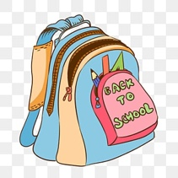
1 | Composition Notebooks  Wide Rule  Labeled with child’s name | 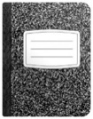
1 | Pack of Printing Paper | 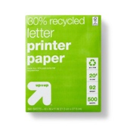
1 | Pencil Box or Pencil Bag  Labeled with child’s name | 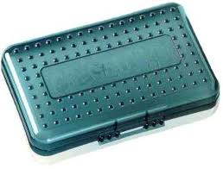
1 | 2 Pocket folders with 3 prongs  Labeled with child’s name | 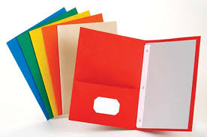
4 | Packages of pencils (10-12 count) | 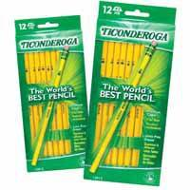
12ct | Glue Sticks | 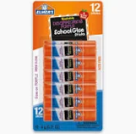
1 | Scissors  Labeled with child’s name | 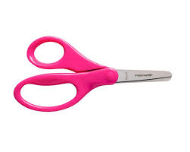
1  Please provide replacement as needed!!! | Headphones  In Ziplock bag labeled with child’s name | 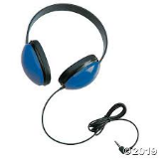
1 | Reusable Water Bottle or  Bottled Water  Labeled with child’s name | 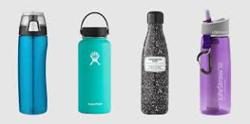
5 | Packages of skinny dry erase markers (black) | 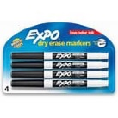
4 | Boxes of Crayons-box of 24 | 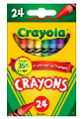
4 | Boxes of tissues | 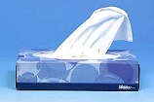
2 | Large bottle of hand sanitizer | 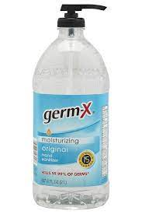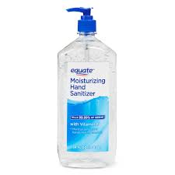
2 | Rolls of paper towels | 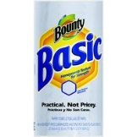
3 pack | Disinfectant Wipes | 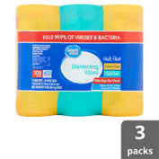
1 | Pack of baby wipes | 
1 | Complete change of clothes (underwear, socks, pant, shirt) in a ZIPLOCK bag labeled with child’s name | 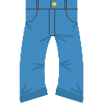

BOYS ONLY-1 box of Gallon size ZIPLOCK Bags
GIRLS ONLY-1 box of Quart size ZIPLOCK Bags

Other Items that we welcome donations:
~ Pre packaged snack (chips, crackers, cookies, fruit gummies, gold fish etc…)
~ extra pencils, crayons, glue sticks, dry erase markers, hand sanitizer, disinfecting wipes, tissues
~ Extra Packs of Copy Paper
~Colored copy paper
~ Handwriting tablets (or pack of handwriting paper)
~Erasers

